328 Bethel Road, Fincastle, Virginia 24090
540.992.2940
CampBethelOffice@gmail.com
www.CampBethelVirginia.org

October 12, 2023

Camp Bethel is accepting on-line applications for a full-time, year-round Food Services Coordinator.

Camp Bethel in Fincastle, Virginia seeks a dependable, caring leader to be our full-time salaried Food Services Coordinator. Food Service ability or experience is required, and staff management experience is preferred. This position is available immediately. Starting benefits package includes salary of $36,000 without optional family/personal medical insurance plan (or $32,000 with optional family/personal medical insurance plan), an employer-paid pension plan, paid vacation leave, professional growth funds, and optional on-site housing and utilities. Camp Bethel is a facility free from tobacco, vaping, alcohol, and drugs. Read the on-line application instructions, position description and more at CampBethelVirginia.org/fsc, or e-mail questions to Camp Director, Hannah Jarrett at Hannah@CampBethelVirginia.org.

Camp Bethel’s current Food Services Coordinator, Rebecca Duncan, will depart October 2023. We celebrate with a big “Thank You!” to Rebecca for her service in Camp Bethel’s Ark Dining Hall and her many years serving on our Summer Camp Staff Team.

Camp Bethel (Fincastle, VA) is the outdoor ministry of the Virlina District Church of the Brethren. Our mission is to foster and build relationships with God, with each other, and all of God’s creation. We live our mission through our Christian camping programs, and availability of our facilities and services to all people.

Summer Camps began at Camp Bethel in 1927, and in 1970 the camp became a year-round Retreat Center for guest groups and churches. To continue and expand our year-round mission, we are accepting applications for Food Services Coordinator at Camp Bethel. The Food Services Coordinator joins our other full-time staff: Camp Director, Hannah Jarrett, Facilities Manager, Mickey Nichols; Program Coordinator, Kathleen Nettnin, and Guest Services Coordinator, Elizabeth Brancati.

Visit www.CampBethelVirginia.org/jobs for on-line application instructions and a detailed position description.

Food Services Coordinator at Camp Bethel

Position Description, revised February 24, 2023

Minimum Qualifications
- Desire to work in Christian hospitality and to fulfill the Camp Bethel Statement of Purpose and Mission.
- High school graduate and at least 21 years old with a valid driver's license.
- Experience or ability in cooking, dietary planning, or food service, and general comfort in a large kitchen. Camp Bethel will provide training for certification in Food Preparation, Food Establishment Operation, and Certified Food Preparer.
- Physical ability to lift loads, handle appliances and equipment, and stand/walk for extended periods.
- Interpersonal skills for relating to coworkers, guest groups, campers, and ability to accept and provide supervision of summer kitchen staff and part-time kitchen staff.
- Self-motivated, punctual, enthusiastic, and good organization for maintaining records, orders, and financial statements.
- Basic computer skills with Microsoft Office: Word; Excel; e-mail; web-based research and ordering.
- Signed acceptance of Camp Bethel/Virlina Personnel Policies, position description, and Record of Agreement.

Camp Statement of Purpose and Mission
Camp Bethel (Fincastle, VA) is the outdoor ministry of the Virlina District Church of the Brethren. Our mission is to foster and build relationships with God, with each other, and all of God’s creation. We live our mission through our Christian camping programs, our services, and making our facilities available to people of all denominations and backgrounds.

Responsible To
The Food Services Coordinator is employed by the Outdoor Ministries Committee (OMC) of the Virlina District Board of the Church of the Brethren upon recommendation of the Camp Director. The Food Services Coordinator is directly responsible to the Camp Director and shall report directly to the Camp Director. In the absence of the Camp Director, the employee shall report to the Program Coordinator. The employee and the Camp Director will perform an annual evaluation to discuss adherence to standards of performance, position description, and personnel policies. Also see the enclosed Camp Bethel Organizational Chart.

General Position Description
The Food Services Coordinator (FSC) arranges supplies and staffing for all food service meals. The FSC works in coordination with the Guest Services Coordinator to ensure preparedness for number of guests, mealtimes, and dietary needs, and to ensure proper cleanliness and readiness of the Ark facilities. The FSC works in coordination with the Program Coordinator and Camp Director to create, support and enhance programs and services. The FSC works in coordination with other full-time staff to enhance the Ark facilities, the camp’s food services and the camp’s overall mission. The FSC is ultimately responsible for ensuring the cleanliness and readiness of the Ark’s facilities (kitchen, dining hall, conference room, restrooms, and decks).

Summer Responsibilities (General)
From Memorial Day through Labor Day, Camp Bethel is primarily a summer camp during weekdays with the FSC arranging supplies and staffing to provide meal services from Sunday evening through Friday evening for between 100 and 200 persons per meal. The FSC will arrange for appropriate coverage by a Certified Food Preparer. The FSC will hire and schedule summer kitchen staff. During most summer weeks, staff are off-duty from Friday evening through Sunday afternoon.

Fall, Winter, and Spring Responsibilities (General)
From late August through May, Camp Bethel is a conference and retreat center during most weekends with occasional weekday use. The FSC will arrange for supplies, staffing, and appropriate coverage by a Certified Food Preparer. Most groups range from 30 to 70 persons, and occasionally groups range from 80 to 200. The FSC will hire and schedule part-time kitchen staff when needed. When weekend meals are not scheduled, the FSC will help in the camp office and with guest preparations.

Responsibilities
- To fulfill the camp’s statement of purpose and mission.
  - Develop and maintain services and a working atmosphere that reflects Christian love. Recognize duties as part of the overall ministries of Camp Bethel and the greater work of the church. During summer camps, support and protect the program for campers and staff. For fall-winter-spring guests, create and uphold an atmosphere of Christian hospitality.
  - Create and maintain services, procedures, and practices in harmony with God and God’s creation, including use of environmentally and globally sensitive products, foods, and practices.
  - Honor the theology and tradition of the Church of the Brethren.

- To supervise the camp’s food services.
- STAFF: Recruit, screen, hire, train, schedule, and supervise seasonal and part-time food service staff upon consultation with and approval by the Camp Director. Report to Camp Director any personnel issues. Only the Camp Director may terminate employment of any full-time or part-time staff.
- ARK FACILITIES AND EQUIPMENT: Ensure cleanliness and readiness of the Ark Kitchen, appliances and equipment, preparation areas, food storage, and the Ark Dining Hall, Ark Conference Room, Ark bathrooms, Ark porches and sidewalks. Work with the Guest Services Coordinator and the Facilities Manager for internal and external cleaning and repairs unmanageable by the food services staff. Arrange for the proper care and maintenance of kitchen equipment and report facility and equipment repair needs to the Facilities Manager.
- MEAL READINESS: The Food Services Coordinator (FSC) arranges supplies and staffing for all food service meals. The FSC works in coordination with the Guest Services Coordinator to ensure preparedness for number and type of guests, timing of meals, and dietary needs. The FSC will arrange for appropriate coverage by a Certified Food Preparer.
- MENU: Plan nutritional, balanced, attractive, varied, plentiful, and tasty meals. Give regard to patrons’ ages and dietary needs. Always consider needs of vegetarians, vegans, and known dietary restrictions. Plan menu in coordination with patrons’ programming needs. Consider food costs and availability.
- FINANCES, BUDGET and INVENTORY: Manage spending, hiring, and scheduling within approved budget line items. Without compromising quality, quantity, or services, the FSC will seek out lower costing foods and supplies and will schedule only necessary employees. Secure two quotes/bids for purchases/services exceeding $2,000 (except for large food orders). Provide detailed records of purchases with accompanying receipts and forms. Order and keep an organized inventory of food/supplies to ensure necessary stock. Coordinate with the Guest Services Coordinator and housekeepers to order cleaning supplies and paper supplies.
- VOLUNTEERS: Recruit, schedule and supervise volunteer helpers when possible to promote positive public relations with our churches and patrons and to supplement use of part-time workers. Recognize the opportunities for ministry that occur when allowing for and working with volunteers.
- HOSPITALITY: In all duties, maintain and promote an atmosphere of professional kindness, flexibility, patience, and love. The Ark Dining Hall and facilities should be a welcoming place for all. Guest hospitality includes providing “Welcome Baskets” (fixings for coffee & tea) for guest groups in rented facilities, out-of-Dining-Hall snacks upon advance reservation by our guests, and occasional out-of-Dining-Hall special events.

- To perform other duties as assigned by the Camp Director that are beneficial to Camp Bethel and that build positive relationships with guests and campers.
- Attend and/or serve at camp fundraisers and Virlina District functions as requested by the Camp Director.
- Participate in scheduled Camp Staff meetings. Attend quarterly meetings of the Outdoor Ministries Committee, and submit a quarterly written report (1-2 paragraphs) for review.
- Maintain professional membership in the American Camp Association (ACA) and the Outdoor Ministries Association of the Church of the Brethren (OMA), (paid for by Camp Bethel). Pursue ongoing professional growth, participate in required sessions of summer staff training, and attend conferences and workshops that strengthen your skills.
- Perform other duties as assigned by the Camp Director.

- To perform and maintain standards, duties, policies, and practices set forth by Camp Bethel, the Virlina District Church of the Brethren, Botetourt County, the Virginia Department of Health, the State of Virginia, the Occupational Safety and Health Administration, and the American Camp Association.
- Maintain adherence to Virginia Department of Health standards and American Camp Association standards through personal research, online and staff library resources, and by attending professional growth workshops and classes when possible and when approved by the Camp Director. Provide necessary documentation of applicable VDH and ACA Standards.
- Learn and maintain all health and safety standards by attending professional growth workshops and classes when possible and when approved by the Camp Director. These are paid for by Camp Bethel.
- Follow policies, procedures and practices set forth by the Camp Director and the Virlina District in matters of staff policies, procedures and programming. Submit relevant forms and documentation when applicable.

General expectation of Camp Bethel’s Food Services
During Summer Camps (late May through early August), Camp Bethel serves 16 FULL meals, Sunday dinner through Friday dinner. Our summer meals must appeal to children and youth and be high quality, nutritious, and plentiful. The FSC is strongly encouraged, when feasible, to use whole foods and fresh produce, and avoid pre-packaged, processed items as much as possible. We promote our Summer Camp meals by saying, “Our family-style meals are nutritious, delicious and plentiful with vegetarian entrée options, and several side options at each meal.” During Summer Camps, an options station will be available at each meal, including cold cereals, toast, dairy, and fruit options for breakfast and fruit, dairy, and salad options for lunch and dinner. During Summer Camps we will provide a “peanut-butter-and-jelly-sandwich-making station” at every meal. During Summer Camps, we provide Family-Style meal service. For most fall-winter-spring guest groups and banquets, we provide Buffet-Style service, but Family-Style can also be a feasible option.

Performance Evaluations Measures:
- Does the employee accept and perform the responsibilities listed on the position description?
- Does the employee seek excellence in the performance of services and responsibilities?
- Does the employee foster and build positive relationships with guests, campers, staff and supporters/volunteers?
- Is the employee a self-starter who can identify, prioritize, and complete necessary tasks without external guidance?
- Does the employee provide timely communication of completed tasks or related progress to other staff?
- Is the employee forthright and transparent in all aspects of their work and responsibilities?
- Is the employee willing to learn new skills and attend professional growth trainings and conferences for this position?
- Is the employee open to new and creative ideas?
- Does the employee seek out ways to serve and help others?
- Does the employee keep workspaces and vehicles clean, and does s/he keep a well-groomed appearance?
- Is the employee a good steward of time, materials, and money, and does the employee plan ahead efficiently?
- Is the employee enthusiastic and able to create excitement in other staff, volunteers, and supporters?
- Does the employee enjoy working at Camp Bethel?

Benefits of this position include:
- Starting salary of $36,000 per year without optional family/personal medical insurance plan, (or $32,000 per year with optional family/personal medical insurance plan). Pay is monthly, and direct deposit is available.
- Pension plan through Brethren Benefit Trust. Employee contributes minimum of 4% of salary, and employer contributes 11%.
- Optional individual/family medical insurance. Employee pays 33.4% of premium, and employer pays 66.6%.
- Optional on-site housing and utilities for an individual or family, pending availability. On-site housing is not assigned any monetary benefit, but Employees who receive optional on-site housing must work an average of 45 hours per week.
- $300+ annual professional growth fund.
- Use of camp vehicle for related work.
- Air-conditioned and heated office; wireless DSL internet access in Ark Dining Hall and Camp Office (fiber-optic coming in late 2023); office desktop-or-laptop computer (Windows 10 or later) provided if needed; free meals when the camp is serving.
- Paid vacation leave, flexible hours, and flexible work-schedule.

Policies and Other Employment Information:
Hours: The Food Services Coordinator will work an average of 40* hours per week. Workdays and hours are flexible and adaptable to the work tasks at hand. The camp office hours are Monday through Friday, 9:00am-5:00pm, and fall-winter-spring guest groups are generally on-site Friday afternoons through Sunday afternoons. For 10-12 weeks while summer campers are on site June through August, all full-time employees are on call (even if not necessarily on site) from Sunday 1:00pm through Friday 7:30pm.
*Note: Employees who receive optional on-site housing must work an average of 45 hours per week.

Paid Vacation: The anniversary for paid vacation purposes shall begin on the date of employment. Camp Bethel Vacation leave is based upon a 6-day workweek. After 3-month probation = 1 week (6 days). After 1 year = 2 weeks (12 days); After 3 years = 2.5 weeks (15 days); After 5 years = 3 weeks (18 days); After 7 years = 3.5 weeks (21 days); After 10 years = 4 weeks (24 days); After 12 years = 4.5 weeks (27 days); after 15 years = 5 weeks (30 days). Unused vacation does not accumulate beyond each calendar year. Vacation is discouraged during summer camp, Sounds of the Mountains Week (in April), Heritage Day Week (first Saturday of October), and over Memorial Day and Labor Day weekends. Workdays and hours are flexible and adaptable to the work tasks at hand, so days off are available in addition to regular vacation leave. Vacation or leave without pay is available with approval by the Camp Director.

Sick Leave: Leave with pay due to injury or illness is accrued at the rate of eight hours (or one day) per month. Sick leave carries over year to year, but sick leave shall not accumulate beyond 45 days. Records pertaining to sick leave shall be maintained at the District Office and shall be available for management review. Vacation leave may be used for additional sick leave if necessary. No compensation is given for sick days remaining at the end of employment.

Family: Per the personnel policies of the Virlina District Board – Church of the Brethren, Inc. “There cannot be direct supervision of a relative or the supervisor cannot promote, review or recommend a salary increase for a relative.”

Probationary Period: Except in cases where the record of agreement provides otherwise, all employees shall have a three-month probationary period at the beginning of employment. Upon completion of the three-month period, the supervisor shall evaluate the progress of the employee (in writing). The initial three-month period shall count toward total tenure and vacation leave; however, probationary employees are not eligible for paid leave during the probationary period.

Other Employment Information: Pay dates are monthly and within five business days of the end of the month. Employee is included in employer-shared Social Security and Medicare. Unemployment insurance is not provided for any employee of a faith-based organization. Each employee is granted six weeks maternity/paternity leave for an adopted or birth baby, and the employee may use short-term disability in combination with accumulated paid sick leave, paid vacation leave, or leave without pay. Up to four workdays with compensation may be granted for a death in the immediate family, including parents, step-parents, parents-in-law, spouse, children, step-children, siblings, grandparents, or grandchildren. One workday may be granted with compensation for the death of another relative. All work-related mileage shall be reimbursed at the standard rate set annually by the Internal Revenue Service and does not included driving to and from work and home. All employees are employed at will. No full time Camp Bethel employee shall have any other regular outside employment that interferes with the regular workdays/hours or duties of the employee.

Ministry: Each employee (paid or volunteer) of Camp Bethel/Virlina District is considered a minister regardless of formal ministerial status or denominational affiliation. Every individual contact made by every individual employee is a reflection upon the mission and ministry of the camp and district, the component congregations and the denomination. All employees will, therefore, manifest a Christ-like spirit, attitude, demeanor and lifestyle in the performance of their duties regardless of location and/or circumstance. No on-site tobacco, smoking, e-cigs, vaping, nicotine, cannabis, drugs, or alcohol; Camp Bethel is a non-smoking/vaping facility. No obscene language.

Camp Bethel programs began at our present location in 1927. Camp Bethel is open year-round for conferences, retreats, festivals, school groups and many other family, church and community events. Supportive congregations, loving guests, faithful families and campers, exceptional food services, a sound program philosophy, excellent full-time and seasonal staff, and hundreds of devoted volunteers have established Camp Bethel as one of the region’s best camping programs. Learn more about Camp Bethel and our interesting history at www.CampBethelVirginia.org. Camp Bethel adheres to over 300 health, safety, program and operational standards of the American Camp Association. Camp Bethel is a member of the Outdoor Ministries Association of the Church of the Brethren.

What is the Virlina District? The Virlina District of the Church of the Brethren is made up of 86 congregations spread across Virginia, West Virginia and North Carolina (hence, “Vir-lina”). The approximately 8,500 members of these congregations own and operate Camp Bethel by electing a volunteer Virlina District Board and Outdoor Ministries Committee. Learn more at www.virlina.org.

Who are the Church of the Brethren? Continuing the work of Jesus: Peacefully, Simply, Together. The Church of the Brethren is a Christian church similar to other mainstream Protestant groups such as Methodists, Baptists and Presbyterians. We base our practices and beliefs on Jesus’ life and teachings and the New Testament. Steadily, lovingly, even radically, Jesus went about saving the world by serving its people. Because we believe Jesus’ message, we seek to do the same. Our other distinctions include our peace position (Matthew 5:44) (shared with Quakers, Mennonites, Amish, and Moravians), emphasis on simple living (Romans 12:2) and Christian service (Luke 22:27), feet-washing during Communion worship service (John 13), and baptism by choice (Acts 2:37-39). The name “Church of the Brethren” was chosen in 1908 to emphasize a sense of family and community and was never intended to sound exclusively male. Rather, the Church of the Brethren views all people as children of God.
“Together, as the Church of the Brethren, we will passionately live and share the radical transformation and holistic peace of Jesus Christ through relationship-based neighborhood engagement. To move us forward, we will develop a culture of calling and equipping disciples who are innovative, adaptable, and fearless.” www.brethren.org

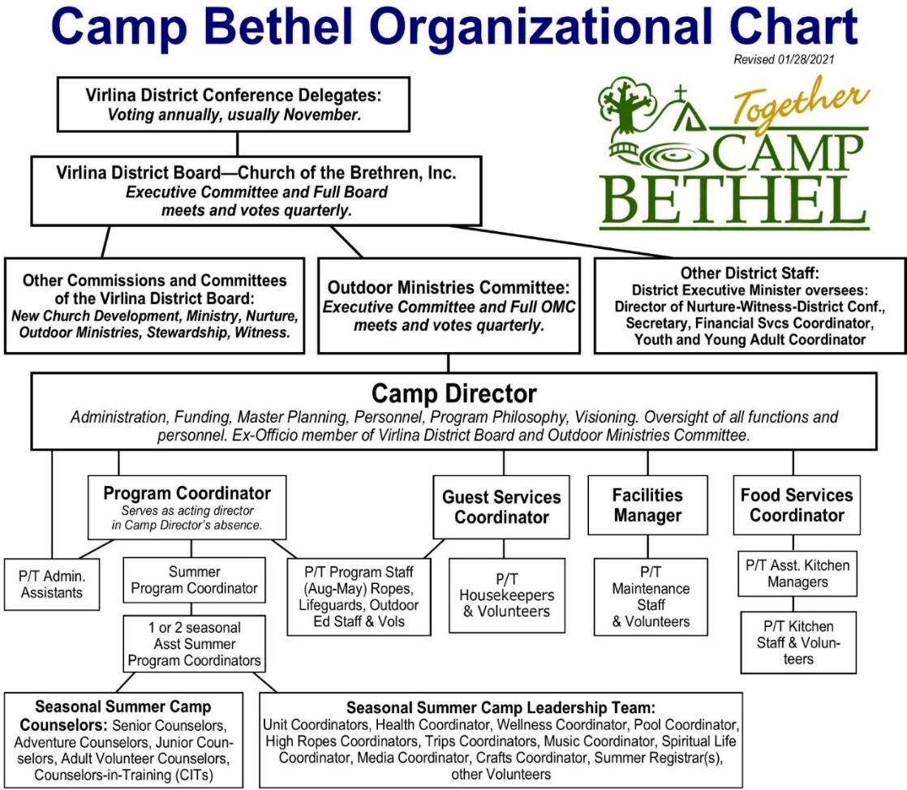
Camp Bethel Food Services Coordinator Applicant Questionnaire:

Instructions:
  - If you have not already done so, read the Food Services Coordinator Position Description and other employment information contained in this document. Read through our web site at www.CampBethelVirginia.org to learn more about us and the district of churches who own Camp Bethel.
  - If you have not already done so, e-mail your résumé and a letter of interest to Hannah Jarrett, Camp Director at Hannah@CampBethelVirginia.org. Send as WORD documents or PDFs, or your email content can serve as your letter.
  - Complete the Required Information (1-6) and the Application Questions (7-16) online at www.CampBethelVirginia.org/food-services-coordinator. Alternatively, provide numbered answers to these (listed below on this page) as a WORD document or a PDF, and return as an e-mail attachment as soon as possible to Hannah Jarrett at Hannah@CampBethelVirginia.org.
  - Upon receipt of your completed application, résumé, and letter of interest, the Camp Director will contact you about whether or not you have been chosen for an interview.

Required Information:
- Your full legal name (first, middle, last).
- Your home, permanent mailing address (number and street or PO Box, city, state, zip).
- Your e-mail, and main phone number where we can respond to you.
- VOLUNTARY DISCLOSURE: Not including traffic violations, have you been convicted of any crime, felony, child abuse, assault, or sexual abuse? Since our primary summer mission is caring for children, we are unable to hire persons with certain prior convictions.
- List THREE persons and their phone numbers who can provide professional reference for you. Describe their relation to your prior experiences or training. Do not list family members as references.
- List TWO persons and their phone numbers who can provide a personal reference for you. Describe their relation to you. Do not list family members as references.

Application Questions:
- Upon reading the Food Services Coordinator position description,
    - What excites you about the possibility of serving at Camp Bethel in this position?
    - Why Camp Bethel?
    - Why now?

- If hired, what date would you be available to begin? This position is available November 1. 2023. Our former Food Services Coordinator lives locally and is available to assist with transition and orientation.

- Describe your experience with or knowledge of Retreat Ministry and/or Summer Camp.

- Describe your experience with or knowledge of dietary restrictions and special diets.
Within reason, we try to accommodate guests’/campers’ dietary restrictions and special diets, both medically necessary and social, including vegetarian, gluten-free, and mild-to-severe food allergies (peanut, tree nut, shellfish, etc.). We also work cooperatively with guests/camper families to accommodate vegans, lactose intolerance, and diabetes..

- If you are hired, you will recruit, hire, train, and supervise 2-3 part-time occasional and/or year-round kitchen staff and 6-8 additional seasonal summer kitchen staff. What is your approach to leadership and teamwork?

- Our guests expect high-quality meals and relatively affordable “church camp” prices. If hired, how would you ensure customer satisfaction while remaining within given budgetary restraints?

- As Camp Director, I trust each employee to complete their tasks and to be forthright and transparent in all aspects of their work and responsibilities. If hired, what would your expectations be of your co-workers?

- What are your personal interests or hobbies?

- Beyond what you’ve described on your résumé, why should we hire you?

- What questions, if any, do you have about this position description, the general expectations, the benefits, policies, and any aspect of Camp Bethel?

